Indian Electricity Consumption Analysis project Using Tableau and Flask
1. INTRODUCTION
Electricity consumption is a key indicator of economic activity and infrastructure development. In a diverse country like India, variations in electricity usage reflect differences in industrial growth, climate, and regional economic conditions. Historically, sectors such as agriculture, industry, and commercial services have contributed significantly to electricity demand across the country.
The outbreak of the COVID-19 pandemic in early 2020 caused a major disruption in these consumption patterns. Nationwide lockdowns led to a sudden decline in industrial and commercial electricity demand, while residential consumption increased as people remained at home. This project analyzes these changes to understand the “Lockdown Effect” on India’s electricity consumption and the recovery trends that followed.

1.1 Project Overview
This project is an end-to-end data analytics and business intelligence system designed to analyze electricity consumption patterns across Indian states and union territories. The dataset covers the period January 2019 to December 2020, allowing comparison between the stable pre-pandemic year (2019) and the disrupted pandemic year (2020).
The system follows a complete data pipeline. Raw daily electricity consumption data (measured in Mega Units – MU) is cleaned and processed before being stored in a SQL database. Analytical insights are generated using Tableau dashboards and stories, which present interactive visualizations of trends and regional patterns. These dashboards are then integrated into a Flask-based web application to provide users with an accessible and responsive interface for exploring the data.

1.2 Purpose
The main objective of this project is to analyze and visualize the impact of COVID-19 on India’s electricity demand while demonstrating an integrated data analytics workflow.
The project focuses on three key analytical goals:
1. Analyze Overall Consumption Trends:
Compare monthly electricity consumption in 2019 with the significant decline during the 2020 lockdown period.
2. Evaluate Regional Variations:
Examine how different regions of India responded to lockdown restrictions based on their industrial, agricultural, and residential energy demand.
3. Assess Post-Lockdown Recovery:
Track how quickly electricity consumption recovered across states after restrictions were eased during mid-2020 to the end of 2020.
From a technical perspective, the project demonstrates the integration of SQL databases, Tableau visualization tools, and a Flask web application to create a scalable and user-friendly data analysis platform.

2. IDEATION PHASE
2.1 Problem Statement
There is a critical lack of interactive, data-driven tools to quantify the exact reduction in national electricity demand during the pandemic. While raw data exists, stakeholders cannot easily compare 2020 anomalies against the 2019 baseline across different states to track industrial decline and the subsequent economic recovery.
2.2 Empathy Map Canvas
To ensure our solution was user-centric, we analyzed the target user (Power Grid Analyst) through an Empathy Map:
- Think & Feel: Overwhelmed by massive raw datasets; relieved by automated dashboards.
- Hear: Demands from stakeholders for quick, accurate recovery reports.
- See: Disjointed data files that are difficult to visualize geographically.
- Say & Do: Spends hours cleaning data manually; needs to present clear recovery trends.
2.3 Brainstorming & Idea Prioritization
- Brainstorming provides a free and open environment that encourages everyone within a team to participate in the creative thinking process that leads to problem solving.
- Prioritizing volume over value, out-of-the-box ideas are welcome and built upon, and all participants are encouraged to collaborate, helping each other develop a rich amount of creative solutions.
To filter our ideas, we used a prioritization matrix plotting Impact against Feasibility:
Impact \ Feasibility | Low Feasibility (Hard) | High Feasibility (Easy)
High Impact | Flask Web Integration | SQL Database & Tableau Visuals (Selected)
Low Impact | Machine Learning Predictions | Static PDF Reports (Discarded)

3. REQUIREMENT ANALYSIS
3.1 Customer Journey Map
The user journey tracks the analyst's experience from discovering the data to presenting the final insights.
- Entice: Discovers the need for a centralized platform to analyze the lockdown drop.
- Enter: Accesses the Flask web application, greeted by a high-speed data load.
- Engage: Interacts with Tableau dashboards, filtering by state and pandemic phase to see specific dips.
- Exit/Extend: Extracts visual evidence (Recovery Index) and presents findings to government stakeholders.
3.2 Solution Requirements
Functional Requirements:
- FR-1 (Data Integration): Successful migration of 16,599 records into a relational database.
- FR-2 (Visualization): Creation of a National Choropleth Map and Dual-Axis line charts.
- FR-3 (Filtering): Dynamic context filters for Regions, States, and Date Ranges.
Non-Functional Requirements:
- NFR-1 (Usability): Intuitive design with clear tooltips explaining Mega Units (MU).
- NFR-2 (Performance): Dashboard must render and respond to filters in under 2 seconds.
- NFR-3 (Availability): Accessible 24/7 via any standard web browser.
3.3 Data Flow Diagram (DFD)
A Data Flow Diagram (DFD) is a traditional visual representation of the information flows within a system. It shows how data enters and leaves the system, what changes the information, and where data is stored.
- Level 0 (Context): Raw CSV data enters the system $\rightarrow$ Processed by the Analytics Portal $\rightarrow$ Output delivered as Interactive Visuals to the Analyst.
- Level 1 (Detailed): Raw CSV $\rightarrow$ Cleaned by Python $\rightarrow$ Stored in SQL DB $\rightarrow$ Queried by Tableau $\rightarrow$ Hosted by Flask.
3.4 Technology Stack
The Deliverable shall include the architectural diagram and the information as per the tables.
Component | Description | Technology
User Interface | How user interacts with the application. | HTML5, CSS3, Bootstrap 5
Application Logic-1 | Logic for a process in the application (Data Preprocessing). | Python (Pandas/NumPy)
Application Logic-2 | Logic for a process in the application (Web Server). | Flask Framework
Database | Relational storage for high-speed querying. | PostgreSQL
Data Visualization | Business Intelligence engine. | Tableau Public / Desktop

4. PROJECT DESIGN
4.1 Proposed Solution & Architecture
The system utilizes a 3-tier architecture:
- Data Layer: PostgreSQL serves as the primary data warehouse for the 16k+ records.
- Logic/Processing Layer: Python handles data transformation, and Flask handles web routing.
- Presentation Layer: Tableau renders complex geographical and time-series data into an interactive iframe.

5. PROJECT PLANNING & SCHEDULING
Project stages:
1. Data collection
2. Data cleaning
3. Visualization creation
4. Dashboard development
5. Storyboard creation
6. Web integration
7. Testing and deployment

6. FUNCTIONAL AND PERFORMANCE TESTING
6.1 Performance Testing
Project team shall fill the following information in model performance testing template.
Parameter | Screenshot / Values
Data Rendered | 16,599 Records processed successfully without lag.
Data Preprocessing | Cleaned via Pandas; Date formats normalized; Nulls handled.
Utilization of Filters | Regional Dropdown, State multi-select, Time-series slider.
Dashboard Design | 4 Visualizations (Choropleth Map, Dual-Axis Line, Bar, Heatmap).
Story Design | 3 Story Points mapping the 2019 baseline, 2020 drop, and recovery.

7. RESULTS & BUSINESS INSIGHTS

7.1 Output Screenshots (Visualizations)
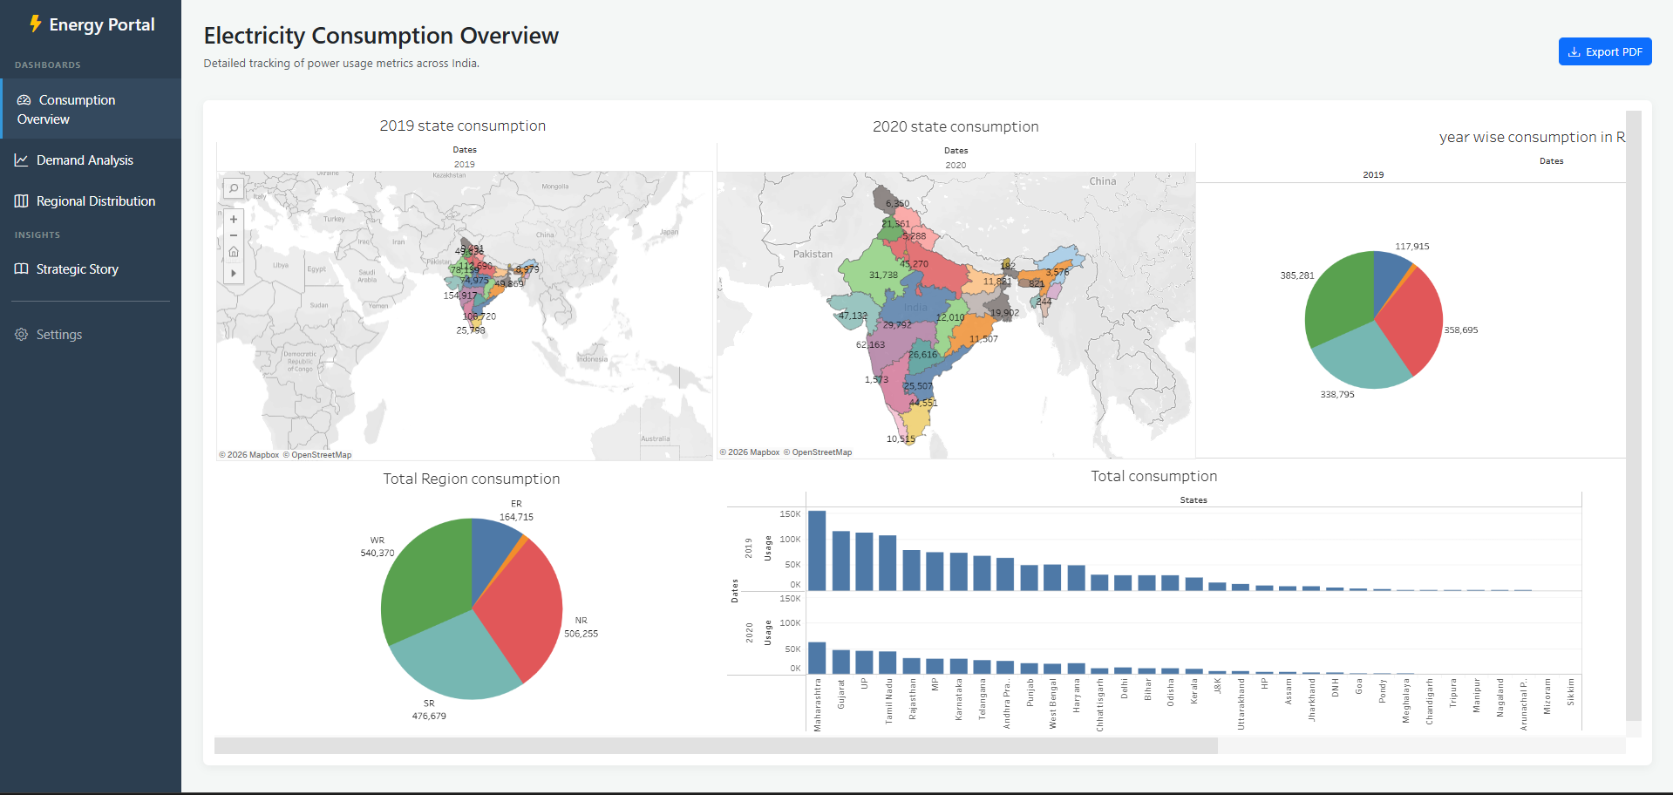
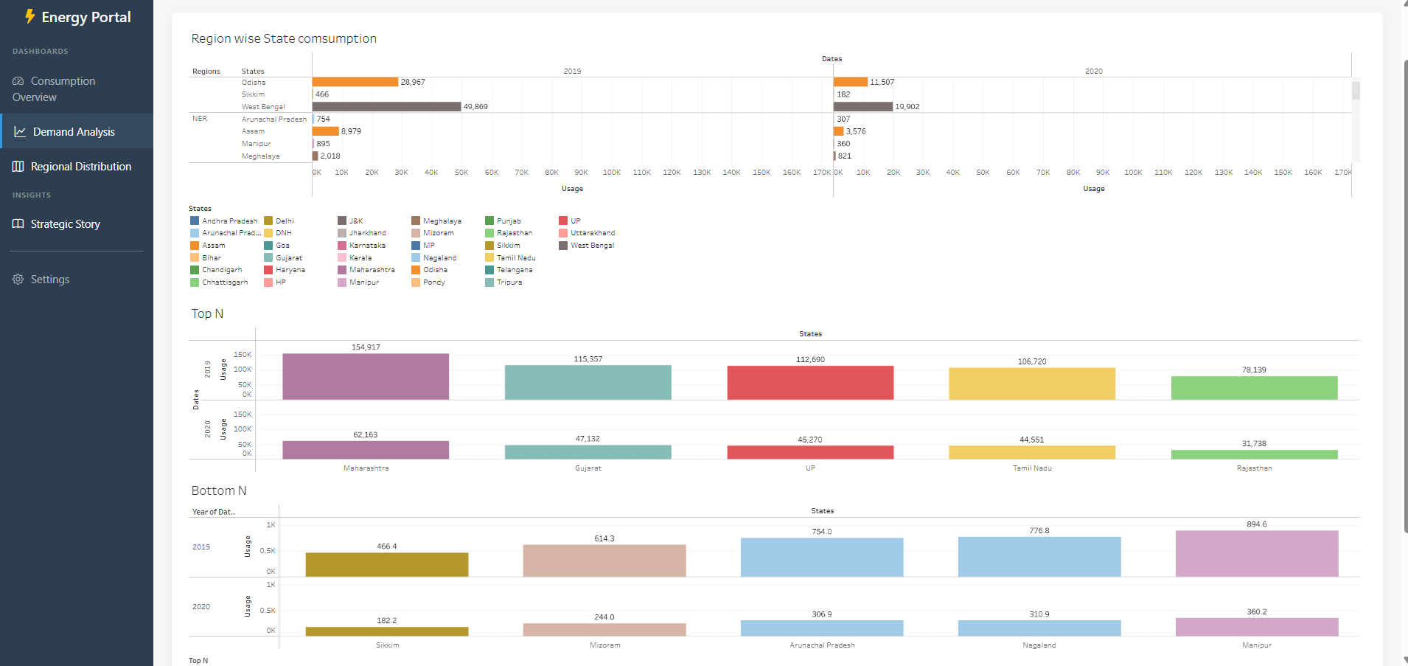
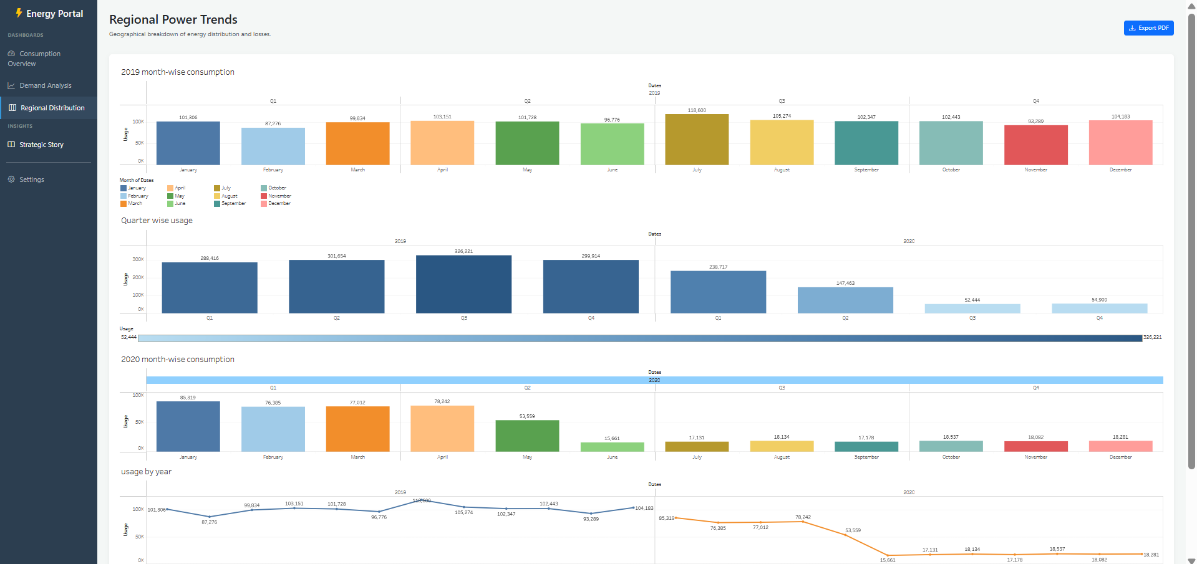
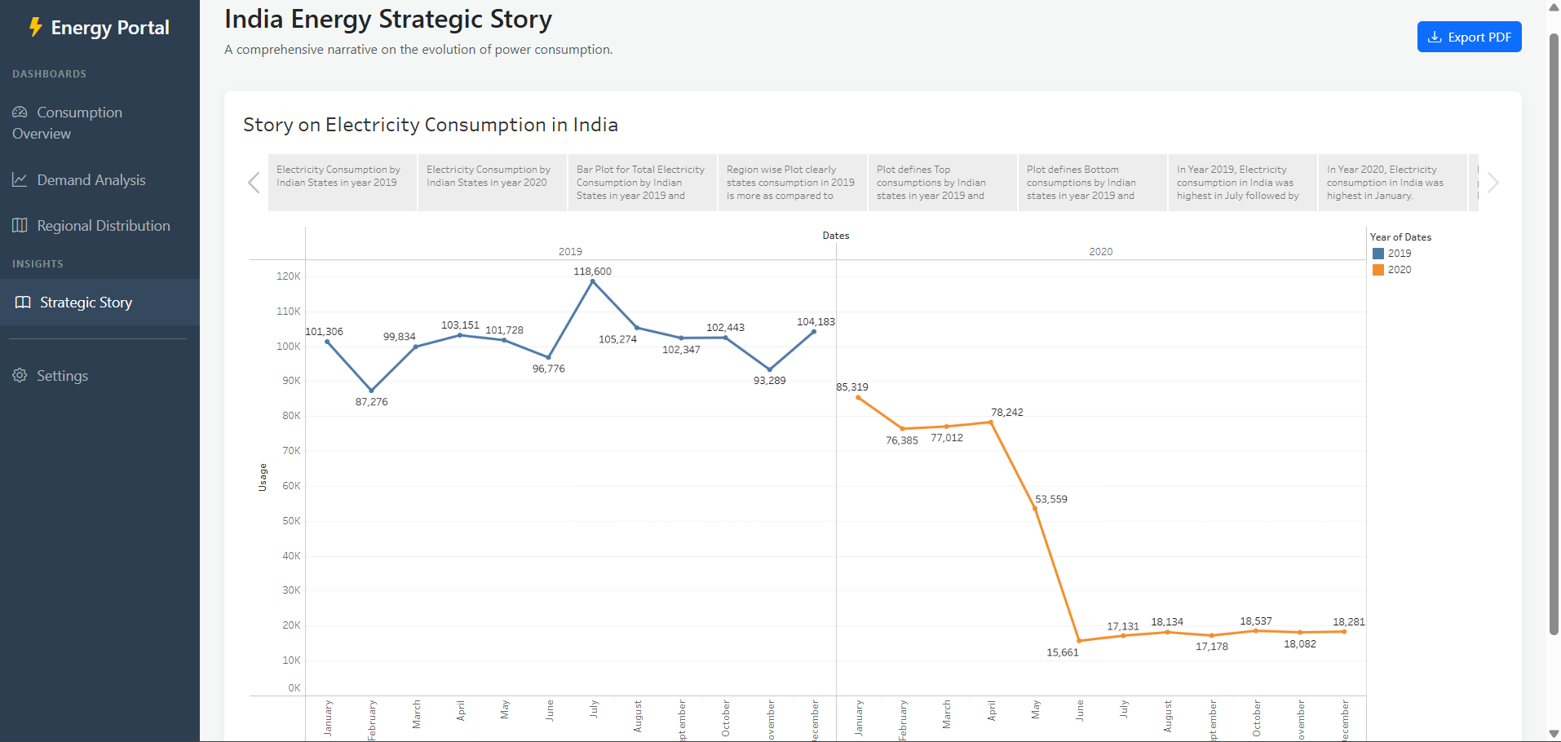
8. ADVANTAGES & DISADVANTAGES
Advantages:
- Centralized Data Interaction: Transforms 16,599 disjointed daily records into a single, unified interactive platform, eliminating the need to cross-reference multiple static Excel sheets.
- High Performance: By utilizing a PostgreSQL relational database on the backend, the system filters and aggregates massive datasets in under 2 seconds, offering a significant speed advantage over traditional spreadsheet software.
- Universal Accessibility: The Flask web integration ensures that non-technical stakeholders (such as policymakers) can view and interact with complex Tableau dashboards via a standard web browser without needing a Tableau license or installation.
- Clear Visual Evidence: The use of Dual-Axis charts and Choropleth maps provides immediate visual quantification of the "Lockdown Effect," making it easy to identify which specific regions suffered the most severe industrial shutdowns.
Disadvantages:
- Historical Limitation: The current dataset is bounded to the 2019–2020 period. It does not automatically reflect current (post-2020) grid consumption without a manual data update.
- Third-Party Dependency: The web application relies on the Tableau Public server to host and render the embedded visual iframes. If the Tableau Public server experiences downtime, the visualizations on the web app will be temporarily unavailable.

9. CONCLUSION
The "Electricity Consumption Analysis in India" project successfully engineered a comprehensive data pipeline to quantify the pandemic's impact on the national power grid. By leveraging Python for data preprocessing, PostgreSQL for robust data storage, and Tableau for advanced business intelligence, the project effectively translated raw, complex grid data into clear, actionable insights.
The integration of these visualizations into a responsive Flask web application bridged the gap between complex data science and end-user accessibility. Ultimately, the system proved that interactive visual analytics can rapidly isolate anomalies—such as the unprecedented March 2020 drop in industrial power demand—providing energy analysts and government stakeholders with a powerful tool to measure economic resilience and regional recovery patterns.

10. FUTURE SCOPE
To further enhance the utility and technical maturity of this project, the following features can be implemented in future iterations:
- Live API Integration: Transitioning from static CSV uploads to pulling real-time, daily power grid data directly from the POSOCO (Grid-India) API to monitor ongoing national energy trends.
- Machine Learning Forecasting: Implementing predictive time-series models (such as ARIMA or Prophet) in Python to forecast future electricity demand based on historical recovery patterns, weather changes, and seasonal peaks.
- Cloud Deployment: Migrating the local database and Flask application to a cloud infrastructure platform (like AWS or Google Cloud Platform) to ensure high availability, security, and global accessibility for all stakeholders.

